Artificial Intelligence-Driven Design and Geometry Optimization in Additive Manufacturing: Recent Advances and Future Directions
Abstract
Artificial intelligence (AI) is becoming an increasingly important tool for additive manufacturing (AM), where design and geometry optimization are often limited by repeated simulation, large design spaces, and manufacturing-related constraints. This review examines recent advances in AI-driven design and geometry optimization in AM, focusing on studies where AI directly supports AM design decisions. A structured literature review was conducted using Scopus as the primary database, with Google Scholar used for citation tracing and supplementary context. After screening studies published from 2018 to 2026, 19 core studies were selected for thematic synthesis. These studies were compared across evidence fields including AI method, AM process, geometry type, validation approach, performance metrics, and reported limitations. The selected studies show that AI supports AM design by accelerating design search, generating candidate geometries, linking design decisions across structural scales, and incorporating manufacturing- or process-aware constraints into optimization. However, key challenges remain, including limited datasets, weak generalization testing, low interpretability, limited process adaptivity, and underdeveloped industrial qualification standards. Overall, AI can support faster and more integrated AM design workflows, but broader adoption will require stronger validation, improved data practices, and closer alignment between AI models and physical manufacturing behavior.
Keywords: artificial intelligence; additive manufacturing; design optimization; topology optimization; generative design; lattice structures; multiscale optimization; manufacturability.
Introduction
Additive manufacturing (AM), commonly known as 3D printing, is a manufacturing process in which parts are built layer by layer directly from a digital model^{1,2}. Unlike traditional subtractive manufacturing that removes material from a solid block, or formative manufacturing that depends on molds and tooling, AM adds material only where it is needed. This allows AM to produce complex shapes such as internal channels, conformal features, and lattice structures that are difficult or impossible to make conventionally^{2,3}. AM now spans multiple process families and material systems, including metals, polymers, ceramics, and composites²⁻⁵. It has become integral to application areas such as aerospace and biomedical engineering, where lightweight structures, customization, and functional integration are often needed^{6,7}.
However, this design freedom also makes AM design more difficult. In traditional design for manufacturing, engineers often simplify parts to fit the limits of manufacturing tools or forming processes. In design for additive manufacturing, geometry itself becomes a more active design variable. A component’s performance may depend on its overall topology, internal architecture, local density, and feature placement. Designers must also consider manufacturing realities such as build orientation, support requirements, thermal distortion, surface quality, and possible defects. Heterogeneous material distribution and multiscale internal architectures add further complexity^{8,9}. As AM moves toward more complex structures, conventional design approaches may struggle to explore the many possible design choices efficiently¹⁰.
Integrating artificial intelligence (AI) into AM is therefore becoming an important way to improve the design process. Rapid advances in machine learning and deep learning have produced data‑driven tools that can handle high‑dimensional search spaces and complex mappings between process, structure, and performance^{11,12}. Recent work shows that AI improves the efficiency of searching, evaluating, and generating AM geometries across metals, polymers, composites, and metastructures. Here, metastructures refer to engineered lattice-like structures with tailored properties. AI is increasingly used not only for prediction but also for design generation and optimization, making it an active component of the AM design process^{13,14,17,20,23}.
Existing reviews have made important contributions by summarizing AI and machine learning applications across different areas of AM. Some reviews provide broad overviews of machine learning, deep learning, and AI-augmented AM across materials, processes, production control, and future challenges^{13-16,18}. Other reviews examine more focused AM contexts, such as specific processes, material systems, sustainability-oriented applications, or printed metamaterials¹⁹⁻²³. However, fewer reviews examine how AI is used specifically as an active part of AM design and geometry optimization. This review addresses that gap by focusing on recent studies in which AI directly supports AM design or geometry optimization. To support this analysis, Scopus was used as the primary database, and Google Scholar was used for citation checking and supplementary context.
This review has two main aims. First, it separates core AM design studies from background literature on AI methods, topology optimization (TO), AM processes, and standardization. Second, it compares the core studies using structured evidence extraction rather than only narrative description. Through this approach, the review aims to clarify how AI is being used in AM design research. It also identifies where the evidence is strongest and highlights the factors that limit transferability to new materials, geometries, processes, and industrial settings.
Methods
Search Strategy
This study was conducted as a structured literature review of AI-driven design and geometry optimization in AM. Scopus was used as the primary bibliographic database. A structured literature search was conducted, and the study selection process was reported using a PRISMA-style flow diagram.
The Scopus search was conducted on June 10, 2026. The exact Scopus query string was:
TITLE-ABS-KEY(("machine learning" OR "artificial intelligence" OR "AI") AND ("topology optimization" OR "generative design" OR "generative artificial intelligence" OR "multiscale" OR "design optimization" OR "geometry optimization") AND ("additive manufacturing" OR "3D printing"))
The initial search identified 422 records. Scopus filters were then applied to retain records published between 2018 and 2026, written in English, classified under the document types “Article” or “Conference paper,” assigned to the source type “Journal,” and listed under the publication stage “Final.” After these filters were applied, 165 records were retained for further screening. Because the core screening set was drawn from Scopus only, cross-database duplicate removal was not required. Records were additionally checked by title and DOI during screening to identify duplicate or repeated records.
Inclusion and Exclusion Criteria
Studies were included as core studies if they met all of the following criteria: (1) the study used an AI or machine-learning method as an active part of design or optimization; (2) the study focused on AM-relevant design, geometry optimization, TO, lattice or metamaterial design, multiscale design, generative design, or manufacturing-/process-aware optimization; (3) the study reported original technical results rather than only reviewing prior work; and (4) the study provided enough methodological and validation detail for comparison.
Studies were excluded from the core synthesis if they were review papers, conference abstracts, unpublished materials, non-peer-reviewed materials, or secondary analyses. Papers were also excluded when they did not make a direct contribution to AM design or geometry optimization, such as studies focused only on process monitoring, defect detection, inspection, or material characterization. Reports with unavailable full text or insufficient methodological and validation detail were similarly excluded from the core set. General AI, TO, AM background, standards, and roadmap sources were not counted as core studies, but were retained as contextual sources when relevant.
Study Selection
The 165 retained Scopus records were screened according to the inclusion and exclusion criteria. After title and abstract screening, 38 reports were selected for full-text assessment. Of these, 19 reports were excluded after full-text review, leaving 19 core studies for thematic synthesis. These 19 studies are treated as a focused evidence set for AI-driven AM design and geometry optimization, rather than as a complete representation of all recent AI applications in AM. The full selection process is summarized in the PRISMA-style flow diagram shown in Figure 1.
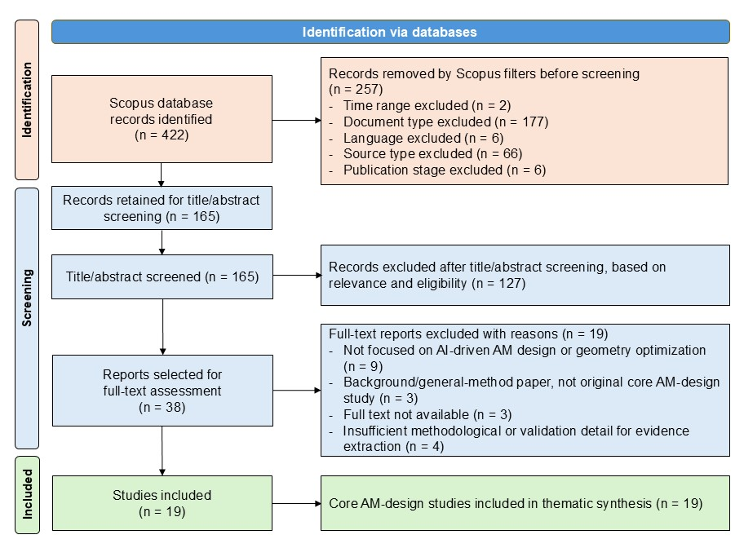Figure 1. PRISMA-style flow diagram showing study identification, screening, and inclusion.
Supplemental Study Selection
Additional sources from 2014 to 2026 were used to provide technical context. These sources included background papers on AM fundamentals, AM challenges, machine learning, deep learning, generative AI model families, TO, and AM standardization. Google Scholar was not used as a primary database for systematic screening. However, it was used for citation checking, background-source identification, and verification of relevant foundational or contextual papers. These supplemental sources were not included in the PRISMA core-study count.
Evidence Extraction, Coding, and Synthesis
Information from the 19 core studies was extracted into a structured evidence table using 11 fields: AI method/role, AM process, material system, geometry class, data source and dataset size, validation type, performance metric, generalization or out-of-distribution (OOD) testing, uncertainty treatment, code/data availability, and reported failure modes or limitations.
Included study | AI method / role | AM process | Geometry class | Validation type | Performance metric | Reported failure modes / limitations
Wang et al.²⁴ | ANN surrogate; predicts auxetic cellular-structure performance and accelerates encoded lattice screening | Laser-based 3D printing | Zig-zag re-entrant auxetic cellular structures | FECs + 3D-printed mechanical testing | R² up to 0.98; 9,876 s for FECs vs. 0.767 s for ANN inference | Limited to encoded auxetic lattice family; speedup excludes FEC data generation, model training, and full workflow
Teimouri et al.²⁵ | DNN surrogates + imperialist competitive algorithm; predicts mass and bending response | Fused deposition modeling (FDM) | Re-entrant auxetic-core sandwich beams | 16 FDM-printed samples tested in three-point bending; one additional specimen used for DNN–experiment comparison | R² ≈ 0.977 for mass; R² ≈ 0.9994 for load-bearing force | Small physical dataset; limited parameter-space validation
Lopez Reyes et al.²⁶ | ANN surrogate trained on AEH scaffold data; predicts scaffold stiffness for faster optimization | Precision extrusion-based 3D printing | Kagome bone-regeneration scaffolds | PCL scaffold fabrication, compression testing, and cell-proliferation testing | 1.02% error against AEH; 43.2% experimental increase over conventional Kagome scaffold | Limited to Kagome scaffold space; some geometries infeasible due to pore/porosity constraints
Xing et al.²⁷ | FoLap online-learning neural model; skips selected FEA/sensitivity steps | 3D-printed soft actuator prototypes | Pneumatic HELC soft actuators | 3D-printed actuator prototypes and actuation tests | Up to 65.1% total computational-time saving for the HELC design problem | Manual refinement was needed for printability; limited process generalization
Hong et al.²⁸ | Deep reinforcement learning + Bayesian optimization; guides metamaterial design search | Material extrusion 3D printing | Kirigami-inspired quasi-zero-stiffness metamaterials | Compression and vibration experiments on printed optimized models | Target load was about 38 N experimentally; low-frequency vibration reduction was demonstrated | Performance depends on target preload and design family; limited broader transfer evidence
Lew and Buehler²⁹ | VAE-LSTM generative model; learns latent trajectories from topology-optimized designs | 3D-printed prototype demonstration | 2D cantilever topology structures | Simulation/ML validation with prototype demonstration | VAE reconstructed 512 × 256 topology images and generated design trajectories in latent space | Mainly one cantilever problem; prototypes mainly showed printability and prototype feasibility, not mechanical validation
Jadhav et al.³⁰ | Conditional denoising diffusion model; generates lattices from target stiffness | Fused deposition modeling (FDM) | 3D lattice unit cells and hybrid TPMS structures | Homogenization/FEM evaluation + FDM printing and compression testing of selected designs | Agreement between target and generated elastic behavior; selected lattices improved energy absorption and compressive strength at lower densities | Errors higher for high-modulus targets; limited OOD evidence and density-sensitive results
Duan and Wu³¹ | ACGAN inverse/forward framework; generates lattice and FFF process parameters from target porosity and compressive-property requirements | Fused filament fabrication (FFF) | Parameterized lattice infill structures | Generated design/process parameters were fabricated and compression-tested | MAPE 6.481% for porosity; 10.208% for compressive modulus | Limited to PLA, selected FFF process window, and three infill patterns
Kok et al.³² | Conditional diffusion model with U-Net denoising architecture; generates static mixers from target fluidic metrics | Resin-based DLP/SLA 3D printing | Static mixer channels with internal obstacles | CFD checking + 18 printed mixer designs with experimental flow/mixing tests | Median relative errors below 25% across pressure difference, concentration, mixing efficiency, and porosity metrics | Sparse training regions reduced accuracy; blank or unrealistic channels required filtering; printed morphology differences affected experimental performance
Ji et al.³³ | 3D-CNN surrogate + BP inverse model; links lattice anisotropy to multiscale design | AM-relevant numerical lattice design | Cubic-BCC-like anisotropic lattice metastructures | Simulation-only validation | Compliance reductions of about 22% and 17% versus baseline | No physical AM validation; limited to selected lattice family and numerical material assumptions
Chen et al.³⁴ | MuLaTOVA with VAE-based lattice generation and neural topology/lattice optimization | AM-enabled multi-lattice design | Heterogeneous multi-lattice structures | Simulation-only validation | FNO-based MuLaTOVA generally achieved lower compliance than comparison methods | No fabrication testing; bounded lattice search and limited process evidence
Wu et al. (biomedical TPMS scaffolds)³⁵ | U-Net micro-strain predictors + Bayesian optimization; optimizes graded scaffold design | Lithography-based ceramic manufacturing (LCM) | Functionally graded TPMS scaffolds | FE-based multilevel simulation + LCM fabrication and micro-CT geometric validation | U-Net regression values > 0.9; optimized scaffolds improved simulated 12-month bone-density outcomes | No in-vivo validation; ceramic printing shape and thickness deviations may affect performance
Wu et al. (functionally graded lattices)³⁶ | DANN; predicts homogenized tensors and sensitivities for graded lattice optimization | Powder bed fusion (PBF) | Functionally graded iso-truss lattices | PBF fabrication, compression/bending tests, and DIC validation | MSE generally < 0.002; optimized lattices produced more uniform strain patterns | Non-smooth lattice transitions, residual stress, deviations, and microcracks affected agreement
Seo and Lee³⁷ | NN surrogate + genetic algorithm; inverse design of multi-material core–shell lattices | PolyJet multi-material 3D printing | Multi-material core–shell BCC lattice structures | PolyJet fabrication + uniaxial compression testing | Optimized Young’s modulus averaged 29.123 MPa versus 9.528 MPa for cylindrical baseline specimens | 24.2% experimental deviation before material-stiffness-ratio correction; depends on BCC geometry, PolyJet materials, and interface/material-property assumptions
Ullah et al.³⁸ | Pix2Pix cGAN; generates AM-constrained topology images with build-space/passive-region restrictions | AM-oriented topology design; LPBF-compatible design context, but no AM fabrication | 2D cantilever-style topology-optimized components | Simulation/ML validation only | 91% artifact-free reliability; AM-relevant restrictions improved generated design feasibility | Artifacts may require manual correction; no FEM revalidation or physical AM testing
Li et al.³⁹ | BP neural network + GA/gradient-based TO; embeds process-property model in TO | Selective laser sintering / laser AM | Process-aware topology-optimized structural examples | Experimental process-property data + numerical optimized structures | 20.35% rudder strain-energy reduction; 9.1% cube stiffness improvement over classical optimization | Final optimized parts not fabricated or tested; depends on PA12 process window and BP-network approximation
Centola et al.⁴⁰ | Bayesian neural-network fatigue/defect models; embeds AM-related fatigue limits into TO | Powder bed fusion–laser beam (PBF-LB) | Fatigue-aware lightweight automotive and aerospace components | Literature-data BNN + TO/FE stress and KI/Kth validation; no new printed component tests | Ti6Al4V bracket Fatigue BNN-derived stress limits were 224 MPa and 79 MPa; KI values of 2.77 and 1.03 MPa·√m were below corresponding Kth values of 4.3 and 2.7 MPa·√m | Sparse literature data; specimen-to-component transfer requires caution; not final fatigue qualification
Iyer et al.⁴¹ | Attention-based 3D U-Net process surrogate; predicts LPBF MSSI cracking/producibility field and supplies PATO sensitivities | Laser powder bed fusion (LPBF) | 3D air-channel coupon and producibility-aware TO domains | Process simulation + experimental coupon validation; PATO design printed and inspected for LPBF cracking | Reduced predicted MSSI cracking risk; PATO-optimized design avoided cracking in experimental validation | Producibility limited to LPBF cracking risk using MSSI; not full AM process qualification
Vulimiri et al.⁴² | Bidirectional convolutional LSTM process surrogate; predicts LPBF residual distortion and gradients for TO | Laser powder bed fusion (LPBF) | Support-free TO beams, table-like structures, and GE bracket | Surrogate/FEA validation + LPBF fabrication and in-situ monitoring | GE bracket FEA maximum distortion reduced from 1705 μm to 439 μm, a 3.88× reduction; zero build failures | Surrogate not accurate enough as a hard constraint; depends on LPBF SS316L assumptions, process parameters, and surrogate-training distribution
Table 1. Condensed evidence table of the 19 core studies used for thematic synthesis. The full evidence-extraction table is provided as Appendix Table A3.
The full evidence-extraction table is provided as Appendix Table A3. A condensed version is included in the main text as Table 1. Table 1 retains the fields most relevant to the Results synthesis: AI method/role, AM process, geometry class, validation type, performance metric, and reported failure modes/limitations.
Each core study was assigned to one primary theme based on the main role of AI in the design workflow. Some studies had secondary relevance to more than one theme, but each was counted under its dominant role. Studies with experimental, process-specific, or physics-based validation were treated as stronger evidence than benchmark-only or simulation-only studies.
Results
The 19 core studies were synthesized according to the primary role of AI in the AM design workflow. Table 1 summarizes the condensed study coding for the 19 core studies, and Table 2 provides a quantitative overview of the study distribution. Together, the studies reveal four main AI roles in AM design: design acceleration, generative design, multiscale and concurrent optimization, and manufacturing- or process-aware optimization. The following subsections examine these roles with attention to cross-study patterns, representative examples, validation strength, and remaining limitations.
Coding dimension | Counts across 19 core studies
Results theme | Design acceleration: 5; generative design: 4; multiscale/concurrent optimization: 5; manufacturing- and process-aware optimization: 5
Primary AI method family | Neural surrogate/predictor models: 11; generative models: 6; AI-guided search or online learning: 2
AM process/application | Polymer/material extrusion: 6; laser/PBF/LPBF/SLS: 6; vat/ceramic/PolyJet: 3; other AM or computational AM-relevant design: 4
Geometry class | Lattice/cellular/scaffold/metamaterial structures: 11; topology/component layouts: 7; fluidic mixer channels: 1
Validation type | Experimental/printed-part or build-based validation: 13; mixed process-data/prototype/literature-data with numerical optimized components: 3; simulation/ML-only validation: 3
Reported metric category | Mechanical/property performance: 14; prediction/generative error: 11; computational/design-time reduction: 5; manufacturability/process-quality outcome: 6; geometry/target-property feasibility: 7
Note: The first five dimensions count each study once using its dominant category. Reported metric categories are multi-label because several studies report more than one outcome measure.
Table 2. Quantitative summary of the 19 core studies included in the Results synthesis.
AI-Driven Design Acceleration in AM
AI can greatly reduce the computational cost of AM design. Recent reviews indicate that design acceleration has become one of the most common applications of AI in AM^{10,17,20,23}. Many AM design tasks require repeated finite element analysis (FEA), iterative topology updates, or large‑scale screening of candidate geometries. These steps become increasingly expensive as the design space grows in size or complexity. AI‑driven acceleration addresses this bottleneck by using learned surrogate models or AI‑guided search strategies to predict design responses and reduce redundant optimization cycles. As a result, the number of costly simulations, experiments, or optimization iterations required before final design validation can be significantly decreased²⁴⁻²⁸.
Across the five core studies in this theme, AI primarily supports early-stage design exploration. The evidence points to three main acceleration pathways. Wang et al.²⁴, Teimouri et al.²⁵, and Lopez Reyes et al.²⁶ used surrogate models to predict design performance before full simulation or testing. Xing et al.²⁷ embedded online learning inside TO to reduce repeated finite-element and sensitivity-analysis steps. Hong et al.²⁸ used AI-guided search to explore a metamaterial design space. Although topology-based and lattice-based problems remain central in this theme, these studies show that AI-driven acceleration is being applied to a broader range of AM design problems, including auxetic structures, sandwich beams, soft actuators, kirigami metamaterials, and biomedical scaffolds.
As summarized in Figure 2, the reviewed studies follow a common pattern. First, an AM design space is defined using geometry, topology, lattice, actuator, or scaffold parameters. An AI model is then used to predict performance or guide the search. The search process identifies promising candidates with fewer direct evaluations. Selected designs are then checked through simulation, fabrication, or experimental testing, and this validation can be used to refine later models.
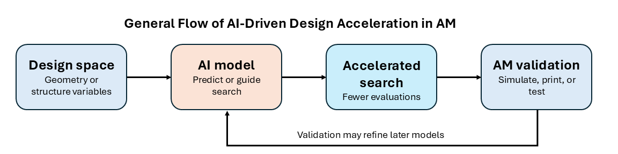Figure 2. General flow of AI-driven design acceleration in AM.
Wang et al.²⁴ provides a clear example of surrogate-based acceleration for AM-relevant auxetic lattice design. Their study encoded zig-zag re-entrant auxetic structures as binary sequences and trained an ANN surrogate to predict negative Poisson's ratio. This allowed rapid screening of candidate structures without running finite-element calculations for every design. In one reported comparison, the ANN evaluated 252 designs in 0.767 s, compared with 9,876 s using finite-element calculations. This corresponds to an inference-time speedup of about 1.3 × 10⁴. Selected optimized structures were then 3D printed and compared with finite-element results. This study demonstrates how surrogate models can speed up AM lattice design exploration while still requiring simulation and experimental validation before final use.
Taken together, these studies show that AI-driven acceleration can make AM design exploration faster and more selective by narrowing large design spaces before final validation. The strongest evidence comes from studies that connect AI-guided design with fabrication or experimental testing. However, the resulting models typically remain tied to the specific design space and validation conditions used in each study. A model that performs well in one geometry family may not transfer reliably to another. For this reason, AI-driven acceleration should be treated as a tool for early-stage design exploration, not a replacement for experimental or physics-based validation.
AI-Driven Generative Design in AM
AI-driven generative design changes the role of computation in engineering from evaluation to creation. In conventional workflows, designers first propose a geometry, which is then refined through simulation, redesign, and validation. In inverse design, this direction is partly reversed: the desired performance target is specified first, and the model searches for or generates geometries capable of meeting that target. Generative AI models support this process by producing candidate designs from target properties, design constraints, or learned latent variables. These approaches build on broader AI model families such as generative adversarial networks (GANs), variational autoencoders (VAEs), and diffusion models⁴³⁻⁴⁵. This capability is especially valuable in AM, where complex internal architectures are often fabricated but are difficult to design through conventional iterative methods alone.
The core studies in this theme differ in what information guides design generation. Lew and Buehler²⁹ used a VAE-LSTM model to map topology-optimized cantilever structures into a latent space, meaning a simplified low-dimensional design representation, and then learned optimization paths within that space. Jadhav et al.³⁰ moved closer to direct inverse design by using a conditional diffusion model to generate 3D lattice unit cells from target stiffness properties. Duan and Wu³¹ used an auxiliary classifier generative adversarial network (ACGAN) framework to link target mechanical properties with both lattice design and FFF process parameters. Kok et al.³² used a conditional diffusion model to generate static-mixer geometries from fluidic performance targets such as pressure drop, concentration, mixing efficiency, and porosity. Collectively, these studies show that generative AI in AM is moving from learning valid design spaces toward generating candidates aligned with mechanical, process, or functional requirements.
Jadhav et al.³⁰ demonstrated diffusion-based inverse design for AM lattice structures through the GLU3D framework. GLU3D, as shown in Figure 3, generated 3D lattice unit cells from target stiffness properties. The method used implicit lattice representations that can be converted into voxel structures for FEA and mesh structures for fabrication. It also introduced hybrid TPMS-based structures that expanded the design space beyond conventional unit cells. Generated lattices were evaluated through simulation, and selected designs were fabricated by FDM and tested in compression. Compared with conventional cubic lattices, the diffusion-generated structures showed improved energy absorption and compressive strength, especially at lower relative densities. This study exemplifies how diffusion models can produce diverse, mechanically targeted lattice candidates while providing pathways for both numerical validation and physical testing.
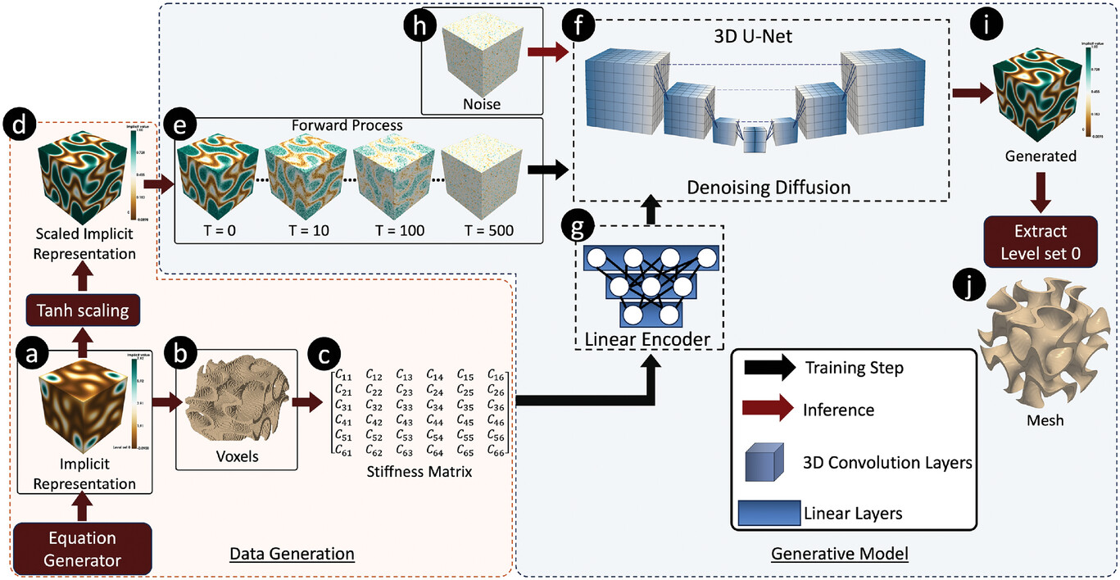
Figure 3. GLU3D workflow for diffusion-based inverse lattice design. Reproduced with permission from Jadhav et al.³⁰.
Generative AI expands AM design by moving from predefined candidate evaluation to target-conditioned generation. However, most models are trained within limited geometry families, material systems, process settings, or target-property ranges. Therefore, generated designs are not automatically reliable, optimal, or transferable to new settings. Across the reviewed studies, generative AI is best viewed as a candidate-generation tool that requires subsequent simulation, fabrication checks, and experimental validation.
AI-Driven Multiscale and Concurrent Optimization in AM
AI-driven multiscale and concurrent optimization addresses a key challenge in AM design: the final performance of a printed part depends on both its global shape and its local architecture. In traditional workflows, the macroscale part layout and the mesoscale lattice or cellular structure are often designed separately. This separation can constrain performance. A local architecture may work well by itself, but its value depends on how it functions within the full part. AI helps connect these levels by learning relationships between unit-cell behavior, effective properties, material distribution, and part-level response. This makes it possible to coordinate geometry and architecture in a more integrated AM design workflow^{10,17,23}.
The five core studies in this theme use AI as a scale-bridging tool. Ji et al.³³ used a 3D-CNN surrogate and inverse model to link anisotropic lattice microstructures with macroscale structural optimization. Chen et al.³⁴ developed a VAE-based multi-lattice framework to distribute different lattice types within topology-optimized structures. Wu et al.³⁵ and Wu et al.³⁶ extended this pattern to graded TPMS scaffolds and functionally graded lattice optimization. Seo and Lee³⁷ broadened the theme to multi-material core-shell BCC lattice beams. Viewed together, these studies show that AI can make heterogeneous AM design more manageable. It can link local architecture and material distribution to part-level design goals. This broadens concurrent AM optimization beyond conventional macro-meso structural design toward graded, multi-lattice, multi-material, and biomedical applications.
Seo and Lee³⁷ provided a representative example because their study focuses on both geometry and material layout. They used a neural-network surrogate with a genetic algorithm to inversely design multi-material core-shell BCC lattice beams. In this study, the design was not only about changing the lattice shape. It also involved assigning different material regions to improve mechanical response. The neural network predicted how lattice configuration and material distribution affected performance. The genetic algorithm then searched for suitable design variables. This example highlights the value of AI for AM designs in which structural performance depends on both lattice geometry and material distribution.
The main challenge is that multiscale AI models often oversimplify the relationship between local architecture and full-part behavior. Homogenized properties and surrogate predictions make optimization more tractable, but they can overlook effects arising from printing defects, material interfaces, and real loading conditions. This is why rigorous validation is especially important in multiscale AM design. The reviewed studies demonstrate strong potential for linking local and global design decisions, yet wider adoption will require clearer evidence that learned local properties remain reliable in fully printed parts.
AI-Driven Manufacturing- and Process-Aware Optimization in AM
A notable development in AI-enabled AM design is the integration of manufacturing considerations directly into optimization. Instead of treating manufacturability as a post-design check, recent studies show how AI can bring process knowledge into the design workflow earlier. In this review, manufacturability is used in a study-specific sense. It does not mean full AM process qualification.
The reviewed studies in this theme show three ways that manufacturing knowledge is incorporated into AI-enabled AM design. At the first level, manufacturing knowledge appears mainly as design constraints. Ullah et al.³⁸ used a Pix2Pix conditional GAN framework to generate topology designs while accounting for AM-related restrictions such as build-space limits and passive regions. These constraints improved producibility without directly embedding process-outcome predictions such as cracking, distortion, or porosity.
At the second level, AI uses process-related data to predict local material or performance properties and then applies those predictions as design limits or objectives. Li et al.³⁹ used a neural network to connect laser AM process parameters with material properties for TO. Centola et al.⁴⁰ employed Bayesian neural networks to account for fatigue performance and defect sensitivity in AM part design. These studies move beyond simple geometric constraints because process-related information affects the optimization. However, the optimization is still not directly guided by predicted build failures such as cracking or residual distortion.
At the third level, AI predicts fabrication outcomes and embeds those predictions directly into the optimization objective or constraints. Iyer et al.⁴¹ integrated a deep-learning surrogate into producibility-aware topology optimization (PATO) for LPBF. Their model predicted a maximum shear strain index, which was used as a cracking-risk indicator. This allows the optimization to consider both structural performance and reduced cracking susceptibility. Vulimiri et al.⁴² used a deep-learning surrogate to predict LPBF residual distortion and include this process-aware response in TO. Their framework allowed distortion-related behavior to influence the design search, and their reported bracket case showed reduced distortion during LPBF validation. Both studies exemplify a more direct form of manufacturing-aware optimization because predicted fabrication outcomes influence the evolving design. The two process-aware examples are illustrated in Figure 4.
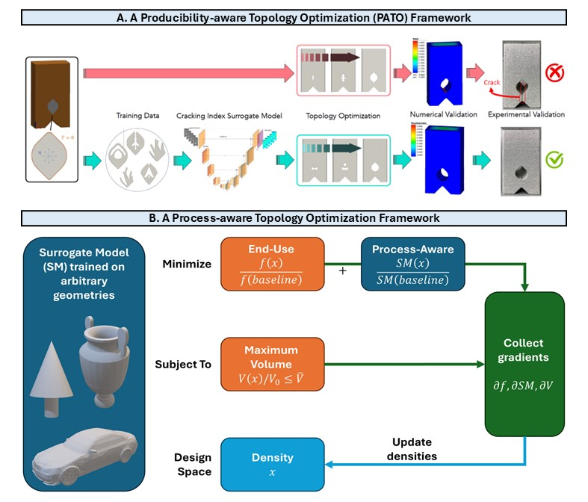
Figure 4. Two process-aware AI workflows for AM topology optimization. (A) PATO framework for LPBF cracking-risk reduction. (B) Surrogate-based framework for process-aware topology optimization. Reproduced with permission from Iyer et al.⁴¹ and Vulimiri et al.⁴².
These reviewed studies indicate a shift from simple manufacturability constraints toward models that incorporate process information more directly. Nevertheless, most models still capture only one part of the manufacturing problem. A model designed for cracking risk, for example, may not capture distortion, fatigue, surface quality, or dimensional accuracy. Moreover, these models are typically developed and validated for specific materials, AM processes, and process settings, which limits out-of-sample transferability. For these reasons, AI can substantially improve manufacturing-aware design optimization, but the resulting models remain application-specific and require careful validation before deployment in new AM contexts.
Discussion
Main Findings and Significance
This review examined how AI is being used in recent AM design and geometry optimization studies. Across the 19 core studies, AI supports AM design through four connected roles: accelerating design search, generating candidate geometries, coordinating design decisions across scales, and incorporating manufacturing- or process-aware constraints into optimization, as illustrated in Figure 5.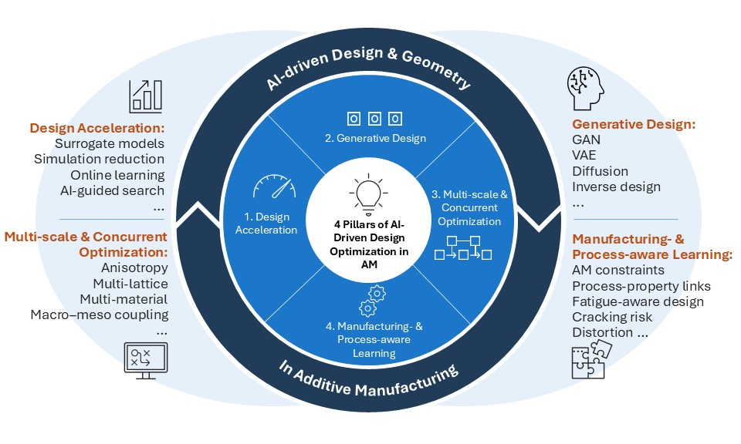Figure 5. Main roles of AI in AM design optimization: design acceleration, generative design, multiscale and concurrent optimization, and manufacturing- or process-aware optimization.
These studies indicate that AI is being integrated into specific stages of the AM design process. Examples include surrogate models that reduce repeated simulation, AI-guided exploration of large design spaces, generative models that produce candidate geometries, and multiscale methods that link local architecture to part-level objectives. Several studies also incorporate process-related risk metrics, such as cracking or distortion, earlier in the design loop. These developments point to an early but growing shift from isolated design steps toward more integrated and process-aware workflows.
The strength of evidence varies across the reviewed studies. Some studies report printed-part testing or process-specific validation, while others remain simulation-only or are limited to narrow geometry, material, or process domains. Consequently, AI should be seen as an emerging support capability in AM design that augments engineering judgment and physics-based analysis rather than replacing them. The most impactful studies explicitly connect AI predictions to design choices and then validate those choices through simulation, fabrication, or process-aware testing. This validation pattern is valuable for practical AM design because it tests whether AI-guided decisions remain meaningful beyond the model itself.
Current Challenges and Future Needs
The reviewed studies reveal five major challenges and future needs.
A first challenge is data coverage. Many reviewed models were trained on narrow datasets, such as one lattice family, topology problem, material, or process window. This restricts generalization and makes it difficult to assess whether a model would perform well under new AM conditions. Addressing this requires better data strategies, which include shared datasets, clearer reporting of data size and preprocessing, transfer learning, online learning, synthetic data generation, and improved data management practices^{46,47}.
A second challenge is limited testing under unseen conditions. Few studies report rigorous out-of-distribution (OOD) testing or uncertainty estimates. As a result, a model may appear accurate within its training range but fail when the geometry, material, loading condition, or process setting changes. Future studies should not only report average prediction error but also identify where the model breaks down and how uncertain its predictions are. This is especially important for process-aware models, where predictions may depend strongly on process settings and material behavior⁴⁸.
A third challenge is interpretability. Many AI methods are judged mainly by accuracy, speedup, or optimized performance. In engineering design, this is not enough. Designers need to understand why a model recommends a geometry, process setting, or material layout. More interpretable models could help engineers identify failure risks and detect unrealistic generated designs. They could also help engineers decide when AI predictions should or should not be trusted. This transparency is particularly important in safety-critical or high-cost AM applications, where design decisions affect reliability, certification, and production cost ^{49,50}.
A fourth challenge is the gap between offline design optimization and adaptive manufacturing. Most studies use AI before fabrication to generate or evaluate a design. Real AM builds, however, evolve during printing due to thermal variation, process drift, local defects, or machine differences. Future AI-driven AM design will likely require closer links with in-situ sensing, digital twins, and adaptive control, where a digital twin refers to a data-updated virtual model of the printing process or printed part. These tools could allow design and manufacturing information to be updated during the build, not only beforehand^{51,52}.
Finally, industrial deployment remains limited. Most studies report simulations, laboratory prototypes, or process-specific demonstrations, with few showing routine production use. Wider adoption will require not only improved models but also practical infrastructure, such as integration with CAD/CAE and AM planning tools, traceable validation records, qualification procedures, trained personnel, and standards for verifying AI-assisted workflows⁵³⁻⁵⁶. Without these elements, many AI methods are likely to remain useful research tools rather than reliable industrial design solutions.
Limitations
This review also has several limitations. First, the core synthesis was based on 19 studies that met the defined inclusion criteria for AI-driven AM design or geometry optimization. This focused set allowed detailed evidence extraction and comparison. However, it does not represent every recent AI application in AM. Studies focused mainly on process monitoring, inspection, defect detection, material characterization, or production control were excluded unless they had a direct design or optimization role.
Second, the reviewed literature remains concentrated in certain design areas. Many core studies focus on TO, lattice structures, scaffolds, or mechanical metamaterials. Broader examples, such as graded architectures, multi-material lattices, soft actuators, static mixers, fatigue-aware design, and process-aware optimization, are included, but non-structural and production-level design applications appear less frequently.
Third, the search method may not have captured every relevant study. Scopus was used as the primary database, so papers outside Scopus may have been missed. The review was also limited to English-language publications, which may introduce language bias. Google Scholar was used only for citation checking and background-source identification because it includes non-peer-reviewed sources and inconsistently ranked results.
Fourth, the review used thematic synthesis rather than meta-analysis. The core studies varied widely in methods, applications, validation approaches, and metrics; therefore pooled statistical comparison was not appropriate. Instead, studies were compared through structured coding, evidence tables, and cross-study themes. This approach supports qualitative comparison, but it cannot yield an overall average effect size for AI-driven AM design.
Finally, the conclusions are limited by uneven reporting across the reviewed studies. Key details such as validation, generalization tests, uncertainty quantification, code/data availability, failure modes were often missing and coded as “not reported.” The review could not independently verify information that was absent from the original papers, so the findings reflect only the published evidence and do not imply broad transferability or production readiness.
Overall Outlook
The reviewed studies show that AI is expanding its role in AM design from simulation acceleration to design generation, multiscale coordination, and manufacturing-aware optimization. However, the evidence remains uneven across materials, processes, validation methods, and application areas. Future progress will require broader datasets, stronger generalization testing, clearer uncertainty reporting, more interpretable models, and better qualification standards. Overall, AI-driven AM design is a promising but still developing design approach. Its long-term value will depend on whether AI models can move beyond narrow demonstrations toward reliable design-support tools for engineering decision-making.
References
1. ISO/ASTM. ISO/ASTM 52900:2021 additive manufacturing - general principles - fundamentals and vocabulary. https://www.iso.org/standard/74514.html, 2021.
2. T. D. Ngo, A. Kashani, G. Imbalzano, K. T. Q. Nguyen, D. Hui. Additive manufacturing (3D printing): a review of materials, methods, applications and challenges. Composites Part B: Engineering. Vol. 143, pg. 172–196, 2018, https://doi.org/10.1016/j.compositesb.2018.02.012.
3. Y. Huang, M. C. Leu, J. Mazumder, A. Donmez. Additive manufacturing: current state, future potential, gaps and needs, and recommendations. Journal of Manufacturing Science and Engineering. Vol. 137, pg. 014001, 2015, https://doi.org/10.1115/1.4028725.
4. A. Vafadar, F. Guzzomi, A. Rassau, K. Hayward. Advances in metal additive manufacturing: a review of common processes, industrial applications, and current challenges. Applied Sciences. Vol. 11, pg. 1213, 2021, https://doi.org/10.3390/app11031213.
5. M. Srivastava, S. Rathee, V. Patel, A. Kumar, P. G. Koppad. A review of various materials for additive manufacturing: recent trends and processing issues. Journal of Materials Research and Technology. Vol. 21, pg. 2612–2641, 2022, https://doi.org/10.1016/j.jmrt.2022.10.015.
6. B. Blakey-Milner, P. Gradl, G. Snedden, M. Brooks, J. Pitot, E. Lopez, M. Leary, F. Berto, A. du Plessis. Metal additive manufacturing in aerospace: a review. Materials & Design. Vol. 209, pg. 110008, 2021, https://doi.org/10.1016/j.matdes.2021.110008.
7. A. Aimar, A. Palermo, B. Innocenti. The role of 3D printing in medical applications: a state of the art. Journal of Healthcare Engineering. Vol. 2019, pg. 5340616, 2019, https://doi.org/10.1155/2019/5340616.
8. M. K. Thompson, G. Moroni, T. Vaneker, G. Fadel, R. I. Campbell, I. Gibson, A. Bernard, J. Schulz, P. Graf, B. Ahuja, F. Martina. Design for additive manufacturing: trends, opportunities, considerations, and constraints. CIRP Annals. Vol. 65, pg. 737–760, 2016, https://doi.org/10.1016/j.cirp.2016.05.004.
9. B. Li, J. Fu, J. Feng, C. Shang, Z. Lin. Review of heterogeneous material objects modeling in additive manufacturing. Visual Computing for Industry, Biomedicine, and Art. Vol. 3, pg. 6, 2020, https://doi.org/10.1186/s42492-020-0041-6.
10. S. Gao, Y. Sun, L. Xi, T. Zhao, Y. Huang, R. He, X. Kang, Y. Li. Recent advances in machine learning-assisted design of additive manufacturing metastructures: a review. Composite Structures. Vol. 372, pg. 119525, 2025, https://doi.org/10.1016/j.compstruct.2025.119525.
11. M. I. Jordan, T. M. Mitchell. Machine learning: trends, perspectives, and prospects. Science. Vol. 349, pg. 255–260, 2015, https://doi.org/10.1126/science.aaa8415.
12. Y. LeCun, Y. Bengio, G. Hinton. Deep learning. Nature. Vol. 521, pg. 436–444, 2015, https://doi.org/10.1038/nature14539.
13. W. L. Ng, G. L. Goh, G. D. Goh, J. S. J. Ten, W. Y. Yeong. Progress and opportunities for machine learning in materials and processes of additive manufacturing. Advanced Materials. Vol. 36, pg. 2310006, 2024, https://doi.org/10.1002/adma.202310006.
14. S. Kumar, T. Gopi, N. Harikeerthana, M. K. Gupta, V. Gaur, G. M. Krolczyk, C. Wu. Machine learning techniques in additive manufacturing: a state-of-the-art review on design, processes and production control. Journal of Intelligent Manufacturing. Vol. 34, pg. 21–55, 2023, https://doi.org/10.1007/s10845-022-02029-5.
15. A. Zolfagharian, L. Jin, Q. Ge, W.-H. Liao, A. Díaz Lantada, F. Franco Martínez, T. Zhang, T. Liu, C. C. L. Wang, M. H. Mosallanejad, R. Ghanavati, A. Saboori, A. De Blas De Miguel, W. Solórzano-Requejo, Y. Cai, X. Dong, H. Qu, N. Samadiani, G. Huang, A. Downey, Y. Fu, L. Yuan, T.-K. Lee, A. A. Baniya, E. Waseem, A. R. Sani, A. Z. Kouzani, Y. Wu, M. P. Nemitz, M. Shirzad, D. Oh, S. Y. Nam, A. F. Bonatti, I. Chiesa, G. M. Fortunato, G. Vozzi, C. De Maria, M. Bodaghi. Roadmap on artificial intelligence-augmented additive manufacturing. Advanced Intelligent Systems. Vol. 8, pg. e202500484, 2026, https://doi.org/10.1002/aisy.202500484.
16. A. I. Saimon, E. Yangue, X. Yue, Z. Kong, C. Liu. Advancing additive manufacturing through deep learning: a comprehensive review of current progress and future challenges. IISE Transactions. Vol. 58, pg. 33–56, 2026, https://doi.org/10.1080/24725854.2024.2443592.
17. J. Jiang, Y. Xiong, Z. Zhang, D. W. Rosen. Machine learning integrated design for additive manufacturing. Journal of Intelligent Manufacturing. Vol. 33, pg. 1073–1086, 2022, https://doi.org/10.1007/s10845-020-01715-6.
18. X. Qi, G. Chen, Y. Li, X. Cheng, C. Li. Applying neural-network-based machine learning to additive manufacturing: current applications, challenges, and future perspectives. Engineering. Vol. 5, pg. 721–729, 2019, https://doi.org/10.1016/j.eng.2019.04.012.
19. S. L. Sing, C. N. Kuo, C. T. Shih, C. C. Ho, C. K. Chua. Perspectives of using machine learning in laser powder bed fusion for metal additive manufacturing. Virtual and Physical Prototyping. Vol. 16, pg. 372–386, 2021, https://doi.org/10.1080/17452759.2021.1944229.
20. M. Hassan, M. Misra, G. W. Taylor, A. K. Mohanty. A review of AI for optimization of 3D printing of sustainable polymers and composites. Composites Part C: Open Access. Vol. 15, pg. 100513, 2024, https://doi.org/10.1016/j.jcomc.2024.100513.
21. I. Malashin, I. Masich, V. Tynchenko, A. Gantimurov, V. Nelyub, A. Borodulin, D. Martysyuk, A. Galinovsky. Machine learning in 3D and 4D printing of polymer composites: a review. Polymers. Vol. 16, pg. 3125, 2024, https://doi.org/10.3390/polym16223125.
22. E. Aktepe, U. Ergün. Machine learning approaches for FDM-based 3D printing: a literature review. Applied Sciences. Vol. 15, pg. 10001, 2025, https://doi.org/10.3390/app151810001.
23. A. Garg, A. Sharma, W. Zheng, L. Li. A review on artificial intelligence-enabled mechanical analysis of 3D printed and FEM-modelled auxetic metamaterials. Virtual and Physical Prototyping. Vol. 20, pg. e2445712, 2025, https://doi.org/10.1080/17452759.2024.2445712.
24. M. Wang, S. Sun, T.-Y. Zhang. Machine learning accelerated design of auxetic structures. Materials & Design. Vol. 234, pg. 112334, 2023, https://doi.org/10.1016/j.matdes.2023.112334.
25. A. Teimouri, M. Alinia, S. Kamarian, S. Saber-Samandari, G. Li, J.-I. Song. Design optimization of additively manufactured sandwich beams through experimentation, machine learning, and imperialist competitive algorithm. Journal of Engineering Design. Vol. 35, pg. 320–337, 2024, https://doi.org/10.1080/09544828.2024.2309862.
26. R. Lopez Reyes, S.-G. Yu, N.-E. Kang, D. Sohn, H. W. Kim, Y.-S. Cho. Artificial neural network-guided optimization of Kagome bone regeneration scaffolds based on asymptotic expansion homogenization results and its validation via additive manufacturing. Journal of Materials Research and Technology. Vol. 39, pg. 5751–5764, 2025, https://doi.org/10.1016/j.jmrt.2025.10.235.
27. Y. Xing, Y. Lu, L. Tong. A function online learning and prediction method for accelerating structural topology optimization and its application to pneumatic soft actuator. Thin-Walled Structures. Vol. 209, pg. 112942, 2025, https://doi.org/10.1016/j.tws.2025.112942.
28. H. Hong, S. Kim, W. Kim, W. Kim, J.-M. Jeong, S. S. Kim. Design optimization of 3D printed kirigami-inspired composite metamaterials for quasi-zero stiffness using deep reinforcement learning integrated with Bayesian optimization. Composite Structures. Vol. 359, pg. 119031, 2025, https://doi.org/10.1016/j.compstruct.2025.119031.
29. A. J. Lew, M. J. Buehler. Encoding and exploring latent design space of optimal material structures via a VAE-LSTM model. Forces in Mechanics. Vol. 5, pg. 100054, 2021, https://doi.org/10.1016/j.finmec.2021.100054.
30. Y. Jadhav, J. Berthel, C. Hu, R. Panat, J. Beuth, A. Barati Farimani. Generative lattice units with 3D diffusion for inverse design: GLU3D. Advanced Functional Materials. Vol. 34, pg. 2404165, 2024, https://doi.org/10.1002/adfm.202404165.
31. C. Duan, D. Wu. Inverse design of lattice structures with target mechanical performance via generative adversarial networks considering the effect of process parameters. Advanced Engineering Informatics. Vol. 65, pg. 103221, 2025, https://doi.org/10.1016/j.aei.2025.103221.
32. Y. E. Kok, R. J. McMullen, I. El Mellas, B. Vuillod, S. Wang, D. J. Irvine, G. Rivers, S. J. Attwood, L. Turyanska, E. Özcan, M. Magnini, R. D. Wildman. Inverse design of static mixers using generative diffusion models, computational fluid dynamics and 3D printing. Chemical Engineering Science. Vol. 330, pg. 123918, 2026, https://doi.org/10.1016/j.ces.2026.123918.
33. Z. Ji, D. Li, C. Zhang, Y. M. Xie, W. Liao. AI-aided design and multi-scale optimization of mechanical metastructures with controllable anisotropy. Engineering Structures. Vol. 310, pg. 118134, 2024, https://doi.org/10.1016/j.engstruct.2024.118134.
34. J. Chen, M. Baldwin, S. P. Narra, C. McComb. Multi-lattice topology optimization via generative lattice modeling. Journal of Mechanical Design. Vol. 147, pg. 051707, 2025, https://doi.org/10.1115/1.4067528.
35. C. Wu, B. Wan, A. Entezari, J. Fang, Y. Xu, Q. Li. Machine learning-based design for additive manufacturing in biomedical engineering. International Journal of Mechanical Sciences. Vol. 266, pg. 108828, 2024, https://doi.org/10.1016/j.ijmecsci.2023.108828.
36. C. Wu, J. Luo, J. Zhong, Y. Xu, B. Wan, W. Huang, J. Fang, G. P. Steven, G. Sun, Q. Li. Topology optimisation for design and additive manufacturing of functionally graded lattice structures using derivative-aware machine learning algorithms. Additive Manufacturing. Vol. 78, pg. 103833, 2023, https://doi.org/10.1016/j.addma.2023.103833.
37. Y. Seo, S. Lee. AI-guided design optimization of core-shell BCC lattices to achieve ultrahigh stiffness via multi-material 3D printing. Thin-Walled Structures. Vol. 219, pg. 114299, 2026, https://doi.org/10.1016/j.tws.2025.114299.
38. A. Ullah, K. Asami, L. Holtz, T. Röver, K. Azher, K. Bartsch, C. Emmelmann. A machine learning approach for mechanical component design based on topology optimization considering the restrictions of additive manufacturing. Journal of Manufacturing and Materials Processing. Vol. 8, pg. 220, 2024, https://doi.org/10.3390/jmmp8050220.
39. S. Li, H. Wei, S. Yuan, J. Zhu, J. Li, W. Zhang. Collaborative optimization design of process parameter and structural topology for laser additive manufacturing. Chinese Journal of Aeronautics. Vol. 36, pg. 456–467, 2023, https://doi.org/10.1016/j.cja.2021.12.010.
40. A. Centola, A. Ciampaglia, C. Boursier Niutta, F. Berto, D. S. Paolino, A. Tridello. Data driven topology optimization of AM parts accounting for process-affected fatigue performance: application to automotive and aerospace components. International Journal of Fatigue. Vol. 206, pg. 109481, 2026, https://doi.org/10.1016/j.ijfatigue.2026.109481.
41. N. S. Iyer, A. M. Mirzendehdel, S. Raghavan, Y. Jiao, E. Ulu, M. Behandish, S. Nelaturi, D. Robinson. PATO: producibility-aware topology optimization using deep learning for metal additive manufacturing. International Journal on Interactive Design and Manufacturing. Vol. 18, pg. 7459–7476, 2024, https://doi.org/10.1007/s12008-024-01905-z.
42. P. S. Vulimiri, S. Garner, A. C. To. Process-aware topology optimization leveraging deep learning surrogate model-based functions for laser powder bed fusion. Additive Manufacturing. Vol. 118, pg. 105094, 2026, https://doi.org/10.1016/j.addma.2026.105094.
43. I. J. Goodfellow, J. Pouget-Abadie, M. Mirza, B. Xu, D. Warde-Farley, S. Ozair, A. Courville, Y. Bengio. Generative adversarial nets. Advances in Neural Information Processing Systems 27. Vol. 27, pg. 2672–2680, 2014, https://proceedings.neurips.cc/paper/5423-generative-adversarial-nets.
44. D. P. Kingma, M. Welling. Auto-encoding variational Bayes. Proceedings of the 2nd International Conference on Learning Representations, 2014, https://openreview.net/forum?id=33X9fd2-9FyZd.
45. J. Ho, A. N. Jain, P. Abbeel. Denoising diffusion probabilistic models. Advances in Neural Information Processing Systems 33. Vol. 33, pg. 6840–6851, 2020, https://proceedings.neurips.cc/paper/2020/hash/4c5bcfec8584af0d967f1ab10179ca4b-Abstract.html.
46. Y. Tang, M. Rahmani Dehaghani, G. Gary Wang. Review of transfer learning in modeling additive manufacturing processes. Additive Manufacturing. Vol. 61, pg. 103357, 2023, https://doi.org/10.1016/j.addma.2022.103357.
47. Y. Zhang, M. Safdar, J. Xie, J. Li, M. Sage, Y. F. Zhao. A systematic review on data of additive manufacturing for machine learning applications: the data quality, type, preprocessing, and management. Journal of Intelligent Manufacturing. Vol. 34, pg. 3305–3340, 2023, https://doi.org/10.1007/s10845-022-02017-9.
48. Z. Wang, C. Jiang, P. Liu, W. Yang, Y. Zhao, M. F. Horstemeyer, L.-Q. Chen, Z. Hu, L. Chen. Uncertainty quantification and reduction in metal additive manufacturing. npj Computational Materials. Vol. 6, pg. 175, 2020, https://doi.org/10.1038/s41524-020-00444-x.
49. Q. T. Nguyen, T.-C. Truong, T. P. Nguyen, T.-N. Tran, J. Mesicek, M. Pagac. Explainable artificial intelligence in additive manufacturing: a systematic review on method convergence and assessment of standardization gaps. MM Science Journal. pg. 8639–8647, 2025, https://doi.org/10.17973/MMSJ.2025_10_2025095.
50. Q. Liu, W. Chen, V. Yakubov, J. J. Kruzic, C. H. Wang, X. Li. Interpretable machine learning approach for exploring process-structure-property relationships in metal additive manufacturing. Additive Manufacturing. Vol. 85, pg. 104187, 2024, https://doi.org/10.1016/j.addma.2024.104187.
51. M. S. Ahmmed, L. Khan, M. A. Mahmood, F. Liou. Digital twins, AI, and cybersecurity in additive manufacturing: a comprehensive review of current trends and challenges. Machines. Vol. 13, pg. 691, 2025, https://doi.org/10.3390/machines13080691.
52. L. Tudorache, Ö. Babur, S. S. Lucas, M. G. J. van den Brand. Current approaches to digital twins in additive manufacturing: a systematic literature review. Progress in Additive Manufacturing. Vol. 10, pg. 10819–10853, 2025, https://doi.org/10.1007/s40964-025-01262-7.
53. America Makes, ANSI Additive Manufacturing Standardization Collaborative. Standardization roadmap for additive manufacturing, version 3.0. https://share.ansi.org/Shared%20Documents/Standards%20Activities/AMSC/AMSC_Roadmap_July_2023.pdf, 2023.
54. America Makes, ANSI Additive Manufacturing Standardization Collaborative. Gaps progress report against the standardization roadmap for additive manufacturing, version 3.0. https://www.ansi.org/standards-news/all-news/4-23-25-april-2025-gaps-progress-report-released-by-america-makes-and-ansi-amsc, 2025.
55. ISO. ISO/TC 261: additive manufacturing. https://www.iso.org/committee/629086.html, n.d. Accessed 10 April 2026.
56. ISO/ASTM. ISO/ASTM 52920:2023 additive manufacturing – qualification principles – requirements for industrial additive manufacturing processes and production sites. https://www.iso.org/standard/76911.html, 2023.

